

DIGI CLASS

Submitted to the
Department of Master of Computer Applications
in partial fulfilment of the requirements
for the Project (MCA51)

by

Anusha Bai N

Chethan Venkatesh
Assistant Professor

Ramaiah Institute of Technology
(Autonomous Institute, Affiliated to VTU)
Bangalore – 54

2019

DEPARTMENT OF MASTER OF COMPUTER APPLICATIONS

CERTIFICATE

This is to certify that the project entitled DigiClass is carried out by

Student Name USN
1)Anusha Bai N 1MS17MCA06

students of 5th semester, in partial fulfillment for the Project (MCA51), during the academic year 2019-2020.

Guide Head of the Department
Chethan Venkatesh

Name of Examiners Signature with Date

DECLARATION

I hereby declare that the project report entitled “Digi Class“ based on study undertaken by me, towards the partial fulfilment for the Project (MCA51) carried out during the 5th semester, has been compiled purely from the academic point of view and is, therefore, presented in a true and sincere academic spirit. Contents of this report are based on my original study and findings in relation there to are neither copied nor manipulated from other reports or similar documents, either in part or in full, and it has not been submitted earlier to any University/College/Academic institution for the award of any Degree/Diploma/Fellowship or similar titles or prizes and that the work has not been published in any specific or popular magazines.

Place: Bangalore Anusha Bai N
Date: 1MS17MCA06

Abstract

Digi-class basically a file sharing system where a teacher will upload a files(pdf)and Students can then view the file with given username and password. Student can listen to audio which is converted from text to speech. Using this app teacher can share the documents instantly to students using subject code. Student can view the documents study and text to speech can be converted.

Table of contents
- Introduction
  - Problem Definition
- Functional Requirements
- Modules Descriptions
- Design Model
4.1 Flow diagram of the project
- Implementation
  - Code snippets of the functional requirements
- User Interfaces/Screenshots with Descriptions
- Conclusion and Scope for Further Enhancement
- Bibliography

Introduction
As the technology is growing in 21st century we need to adopt as well. Nowadays it
is problem to share the notes between students and teacher. Teacher can share the PDf file to the student using this app.
Teacher can upload a PDF file using a unique code. Once the PDF file is uploaded students can login and download the app using that unique code. Once student downloads the file text to speed conversion is happening. The text on the PDF is converted to voice.
This project focused on how to save time on sharing the file and instead of reading this app will speak the text so that it saves the student time instead of studying. If a student needs to revise the concept after studying this app helps them very well.

  - Problem Statement

- Sharing the file through online
- Sharing the file is very problematic some app requires to send file to unique users instead of all the users or need to create a group bu adding all the users to the group
- It makes all the registered student to be able to download the file using the unique code.
- Text to speech
  - Students are very lazy to revise the studied concepts of very lazy to learn first time itself
  - They want others to read for them so this app convert text to speech so that it makes them to study and understand the concept
  - Some students do not memorize the concept they memorize the text.

1.2 Objectives
The objectives of developing this system were:
1)To reduce the time in sharing the file of creating a group for sharing file
2)To reduce student time in revising and to avoid making student memorizing the only the text and make them understand the concepts

Functional Requirements

- The application should be able to register teachers and student
- The application should be able to provide feature to upload and download using unique code
- The application should provide only download feature for student
- The application should be able to convert text to speech, text should be from the PDF content

Module Descriptions
The main function is to Share the file and convert the text to speech

File Sharing
- Teacher will be able to upload the file using unique code
- Student can download the file using the unique code
Text to Speech
- Once student downloads the file and text to speech is converted
- The text inside the PDF is converted

- Design Model

- Process Flow Diagram of the project

Users in DigiClass
- Teacher
- Student

Teacher Uploading and Download File Flow Diagram

Start

Upload and Download

Uploading PDF File
Download file using Unique code

Store in Firebase
Download PDF file using unique code

Text to Speech

Stop

Student Download PDF file

Start

Unique code

Download file and view

Text to Speech file Content

Stop

5.Implementation Code snippets of the functional requirements

Activity_file_upload.xml

<?xml version="1.0" encoding="utf-8"?>
<androidx.constraintlayout.widget.ConstraintLayout xmlns:android="http://schemas.android.com/apk/res/android"
xmlns:app="http://schemas.android.com/apk/res-auto"
xmlns:tools="http://schemas.android.com/tools"
android:layout_width="match_parent"
android:layout_height="match_parent"
tools:context=".FileUpload">
<ScrollView
android:layout_width="0dp"
android:layout_height="0dp"
android:textAlignment="center"
app:layout_constraintBottom_toBottomOf="parent"
app:layout_constraintEnd_toEndOf="parent"
app:layout_constraintHorizontal_bias="0.0"
app:layout_constraintStart_toStartOf="parent"
app:layout_constraintTop_toTopOf="parent"
app:layout_constraintVertical_bias="0.0">
<LinearLayout
android:layout_width="match_parent"
android:layout_height="wrap_content"
android:orientation="vertical"
android:gravity="center"
android:textAlignment="center">
<Button
android:id="@+id/button5"
android:layout_width="match_parent"
android:layout_height="wrap_content"
android:layout_marginLeft="10dp"
android:layout_marginTop="10dp"
android:layout_marginRight="10dp"
android:layout_marginBottom="0dp"
android:onClick="chooseFile"
android:text="Choose File"
android:textAlignment="center" />
<EditText
android:id="@+id/editText7"
android:layout_width="match_parent"
android:layout_height="wrap_content"
android:layout_marginLeft="10dp"
android:layout_marginTop="10dp"
android:layout_marginRight="10dp"
android:layout_marginBottom="0dp"
android:ems="10"
android:hint="@string/fileName"
android:inputType="textPersonName"
android:textAlignment="center" />
<Button
android:id="@+id/button6"
android:layout_width="match_parent"
android:layout_height="wrap_content"
android:layout_marginLeft="10dp"
android:layout_marginTop="10dp"
android:layout_marginRight="10dp"
android:layout_marginBottom="0dp"
android:onClick="uploadFile"
android:text="Upload" />
</LinearLayout>
</ScrollView>
</androidx.constraintlayout.widget.ConstraintLayout>

FileUpload.java

package com.example.digitalclass;
import androidx.annotation.NonNull;
import androidx.annotation.Nullable;
import androidx.appcompat.app.AppCompatActivity;
import androidx.core.app.ActivityCompat;
import androidx.core.content.ContextCompat;
import android.Manifest;
import android.app.ProgressDialog;
import android.content.Intent;
import android.content.pm.PackageManager;
import android.net.Uri;
import android.os.Bundle;
import android.view.View;
import android.widget.EditText;
import android.widget.TextView;
import android.widget.Toast;
import com.google.android.gms.tasks.OnFailureListener;
import com.google.android.gms.tasks.OnSuccessListener;
import com.google.android.gms.tasks.Task;
import com.google.firebase.firestore.DocumentReference;
import com.google.firebase.firestore.FirebaseFirestore;
import com.google.firebase.storage.FirebaseStorage;
import com.google.firebase.storage.OnProgressListener;
import com.google.firebase.storage.StorageReference;
import com.google.firebase.storage.UploadTask;
import java.security.Permission;
import java.util.HashMap;
import java.util.Map;
public class FileUpload extends AppCompatActivity {
private Uri pdfUri = null;
private FirebaseStorage storage;
private EditText ed7;
private FirebaseFirestore db;
private StorageReference mStorageRef;
private Intent intent;
private ProgressDialog progressDialog;
@Override
protected void onCreate(Bundle savedInstanceState) {
super.onCreate(savedInstanceState);
setContentView(R.layout.activity_file_upload);
storage = FirebaseStorage.getInstance();
ed7 = findViewById(R.id.editText7);
db = FirebaseFirestore.getInstance();
mStorageRef = FirebaseStorage.getInstance().getReference();
intent = new Intent(this, MainActivity.class);
}
public void uploadFile(View view) {
if (pdfUri != null) {
//HI there
//String fileName = System.currentTimeMillis()+"";
progressDialog = new ProgressDialog(this);
progressDialog.setProgressStyle(ProgressDialog.STYLE_HORIZONTAL);
progressDialog.setTitle("Uploading File...");
progressDialog.setProgress(0);
progressDialog.show();
Uri file = pdfUri;
String fileName = System.currentTimeMillis() + "";
StorageReference riversRef = mStorageRef.child("pdf/" + fileName);
riversRef.putFile(file)
.addOnSuccessListener(new OnSuccessListener<UploadTask.TaskSnapshot>() {
@Override
public void onSuccess(UploadTask.TaskSnapshot taskSnapshot) {
String downloadUrl;
Task<Uri> downloadUrl1 = taskSnapshot.getMetadata().getReference().getDownloadUrl();
downloadUrl1.addOnSuccessListener(new OnSuccessListener<Uri>() {
@Override
public void onSuccess(Uri uri) {
String downloadUrl = uri.toString();
Map<String, Object> fileURL1 = new HashMap<>();
fileURL1.put("url", downloadUrl);
db.collection("filesURL")
.document(ed7.getText().toString())
.set(fileURL1)
.addOnSuccessListener(new OnSuccessListener<Void>() {
@Override
public void onSuccess(Void aVoid) {
progressDialog.hide();
startActivity(intent);
}
})
.addOnFailureListener(new OnFailureListener() {
@Override
public void onFailure(@NonNull Exception e) {
//Log.w(TAG, "Error adding document", e);
Toast.makeText(FileUpload.this, "Failed on storing file in database", Toast.LENGTH_SHORT).show();
}
});
}
});
//Uri downloadUri = taskSnapshot.getDownload
//End of URL storing to the storage
}
})
.addOnFailureListener(new OnFailureListener() {
@Override
public void onFailure(@NonNull Exception exception) {
// Handle unsuccessful uploads
// ...
}
})
.addOnProgressListener(new OnProgressListener<UploadTask.TaskSnapshot>() {
@Override
public void onProgress(UploadTask.TaskSnapshot taskSnapshot) {
int currentProgress = (int) (100 * taskSnapshot.getBytesTransferred() / taskSnapshot.getTotalByteCount());
progressDialog.setProgress(currentProgress);
}
})
;
} else {
Toast.makeText(this, "Please choose the file and then upload", Toast.LENGTH_SHORT).show();
}
}
public void chooseFile(View view) {
if (ContextCompat.checkSelfPermission(FileUpload.this, Manifest.permission.READ_EXTERNAL_STORAGE) == PackageManager.PERMISSION_GRANTED) {
selectPDF();
} else {
ActivityCompat.requestPermissions(FileUpload.this, new String[]{Manifest.permission.READ_EXTERNAL_STORAGE}, 9);
}
}
@Override
public void onRequestPermissionsResult(int requestCode, @NonNull String[] permissions, @NonNull int[] grantResults) {
//super.onRequestPermissionsResult(requestCode, permissions, grantResults);
if (requestCode == 9 && grantResults[0] == PackageManager.PERMISSION_GRANTED) {
selectPDF();
} else {
Toast.makeText(this, "Read Permission should be granted inorder to upload File", Toast.LENGTH_SHORT).show();
}
}
private void selectPDF() {
Intent intent = new Intent();
intent.setType("application/pdf");
intent.setAction(Intent.ACTION_GET_CONTENT);
startActivityForResult(intent, 86);
}
@Override
protected void onActivityResult(int requestCode, int resultCode, @Nullable Intent data) {
super.onActivityResult(requestCode, resultCode, data);
if (requestCode == 86 && resultCode == RESULT_OK && data != null) {
pdfUri = data.getData();
Toast.makeText(this, "File is choosen", Toast.LENGTH_SHORT).show();
//25 Min
} else {
Toast.makeText(this, "Please select a File", Toast.LENGTH_SHORT).show();
}
}
}

PDF_Reading.xml

<?xml version="1.0" encoding="utf-8"?>
<androidx.constraintlayout.widget.ConstraintLayout xmlns:android="http://schemas.android.com/apk/res/android"
xmlns:app="http://schemas.android.com/apk/res-auto"
xmlns:tools="http://schemas.android.com/tools"
android:layout_width="match_parent"
android:layout_height="match_parent"
tools:context=".test">
<com.github.barteksc.pdfviewer.PDFView
android:layout_width="match_parent"
android:layout_height="match_parent"
android:id="@+id/testPDF"
></com.github.barteksc.pdfviewer.PDFView>
</androidx.con

PDF_Text_To_Speech_Code.java

import java.util.Locale;
import android.app.Activity;
import android.os.Bundle;
import android.speech.tts.TextToSpeech;
import android.util.Log;
import android.view.View;
import android.widget.Button;
import android.widget.EditText;

public class MainActivity extends Activity implements
TextToSpeech.OnInitListener {

/** Called when the activity is first created. */
private TextToSpeech tts;
private Button btnSpeak;
private EditText txtText;

@Override
public void onCreate(Bundle savedInstanceState) {
super.onCreate(savedInstanceState);
setContentView(R.layout.activity_main);

tts = new TextToSpeech(this, this);

btnSpeak = (Button) findViewById(R.id.btnSpeak);

txtText = (EditText) findViewById(R.id.txtText);

// button on click event
btnSpeak.setOnClickListener(new View.OnClickListener() {

@Override
public void onClick(View arg0) {
speakOut();
}

});
}

@Override
public void onDestroy() {
// Don't forget to shutdown tts!
if (tts != null) {
tts.stop();
tts.shutdown();
}
super.onDestroy();
}

@Override
public void onInit(int status) {

if (status == TextToSpeech.SUCCESS) {

int result = tts.setLanguage(Locale.US);

if (result == TextToSpeech.LANG_MISSING_DATA
|| result == TextToSpeech.LANG_NOT_SUPPORTED) {
Log.e("TTS", "This Language is not supported");
} else {
btnSpeak.setEnabled(true);
speakOut();
}

} else {
Log.e("TTS", "Initilization Failed!");
}
}

private void speakOut() {
CharSequence text = txtText.getText();
tts.speak(text, TextToSpeech.QUEUE_FLUSH, null,"id1");
}
}

6.User Interfaces/Screenshots with Descriptions

Uploading file by entering unique code
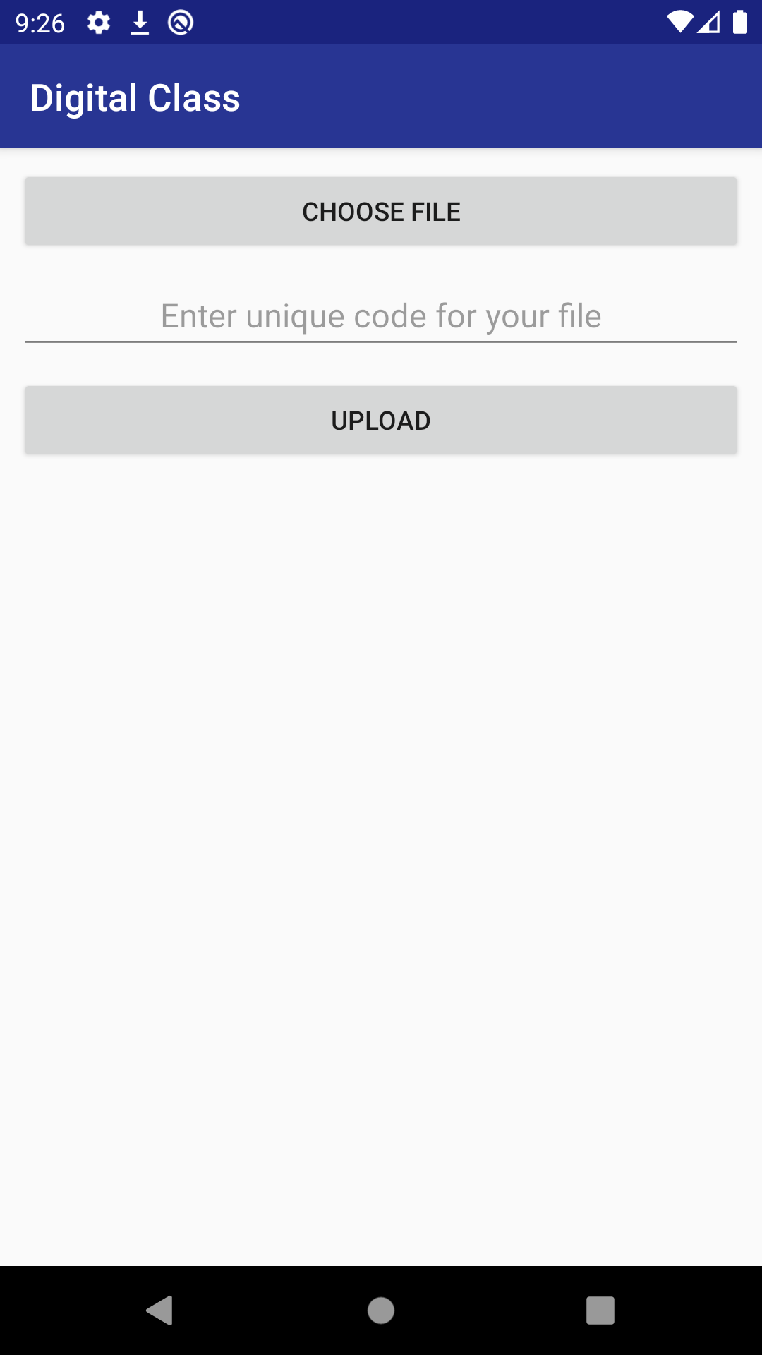

Text To speech conversion activity
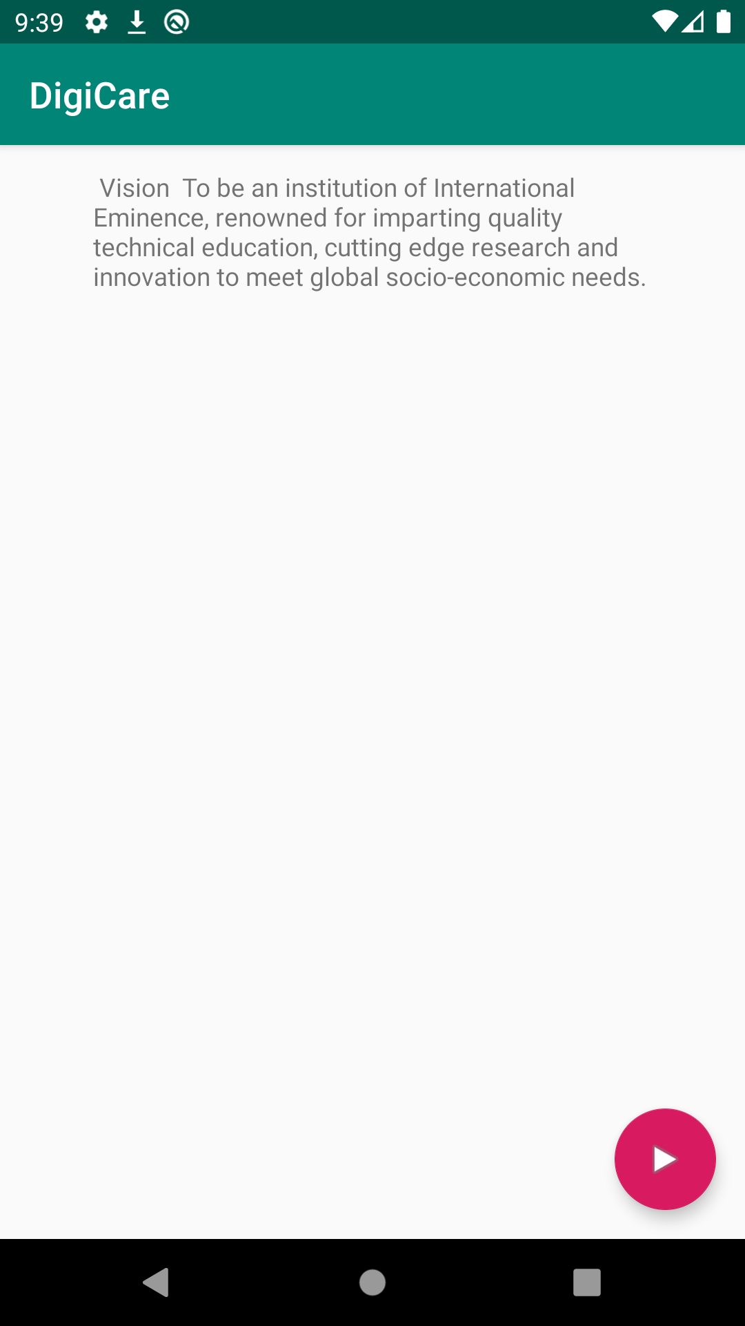

7. Conclusion and Scope for Further Enhancement

In conclusion, this system was developed to share the file so that saving the time. Text to speech to save student time in revising the concept and to make the student memorize the concept instead of memorizing only the text
Finally for this application has room for the enhancement in the future. System should be able to share video, audio file. Playback, rewinding the audio should be added as a feature.

- Bibliography

- Youtube
- Stack overflow
- Github
- Android Developers

